EBOOK WEBSITE DOCUMENTATION

NAMES OF TEAM MEMBERS

NAME | STUDENT ID
RAHIM ALI MALIK | STUDENT ID 1444855
SAAD RASHID | STUDENT ID 1449288
LAIBA ZAHID | STUDENT ID 1444846
MADIHA KHAN | STUDENT ID 1442888

Table of Contents

Introduction ………………………………………02

Existing Scenario …………………………………………02

Proposed Scenario …………………………………………02

- Non-Financial ….……………………………03

- Financial .……………………………………04

Functional Requirements ……………………………………04

Introduction : –
Our client is a famous publisher who publishes books of different categories like comics, novels, story books, General knowledge books, quiz books, journals, etc….. As there is no end for knowledge, which keeps on changing from day to day, the books are needed to be revised for every now and then. As well the stories which keep on coming as there are several writers in the world. And as there are so many publications as such and keep increasing day by day, there by increasing the competition in providing the new information, and to be first to reach out to customers. He also conducts competition for the readers by asking them to send the stories and out of the received stories the best one will be published in the next journal and as well the price will be given to the customers.

OBJECTIVE

It seems like you've provided an extensive outline for a transition to an e-book platform for a publishing company, covering various aspects such as the current scenario, proposed changes, non-financial aspects, financial considerations, and functional requirements.
The provided content seems to include a detailed plan for transforming the publisher's operations and services by adopting digital methods. However, the section titled "ebook objective" seems to be cut off. If you'd like to further elaborate on the specific objectives or if there's anything specific you'd like to discuss regarding e-books, feel free to provide additional details

Accessibility: Make books and publications more accessible to a wider audience globally through digital mediums

Customer Convenience: Offer customers the convenience of purchasing books online in various formats (PDF, hard copy, CD) directly from the publisher.

Engagement & Participation: Encourage customer engagement through competitions, allowing them to submit stories and essays for publication and recognition.

User Interface & Experience: Create a user-friendly website with advanced search options, displaying new releases and high-demand publications prominently.

Enhanced Information Sharing: Enable detailed book descriptions, including author details, book revisions, pricing, and shipping information, to registered users.

Functional Requirements : –

- A database should be created that holds the details of the books, orders, and that of the customers.

- The customers who are registered with the site will alone be able to fetch and see the details of the website.

- The Admin solely should have the rights of uploading the details of the books and as well uploading the books in the PDF document form.

- As soon as the receipt of an order, the customer should be acknowledged with the details of the order, like address (if ordered for the CD or Hard copy) and then ask for the confirmation of the order.

- After the confirmation is received from the user, then only the further process has to be taken place.

- The customer who has requested for the book online in the form of the PDF Document, can only access that document only after the payment is received by the publisher.

- The contact information is also needed to be provided, which includes the details of the dealers of that location, so that the customer can even purchase that book from the dealer.

HOME

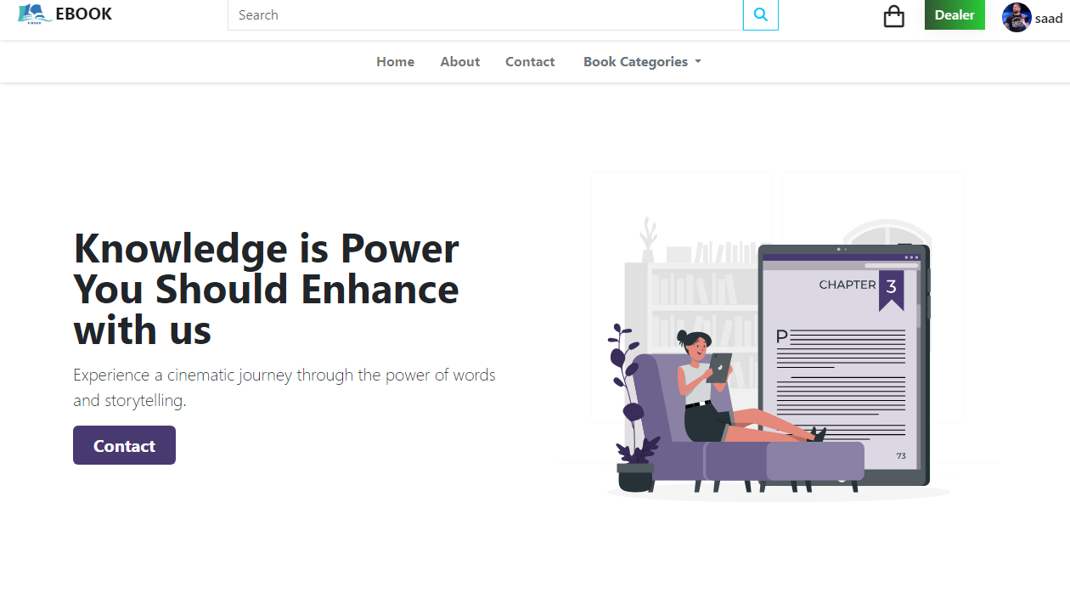 Getting Started

- A modern web browser (Chrome, Edge, etc.).
- Internet connection.

Features
- Stories Book
- Novel
- Comic
- General knowledge Book

ABOUT US

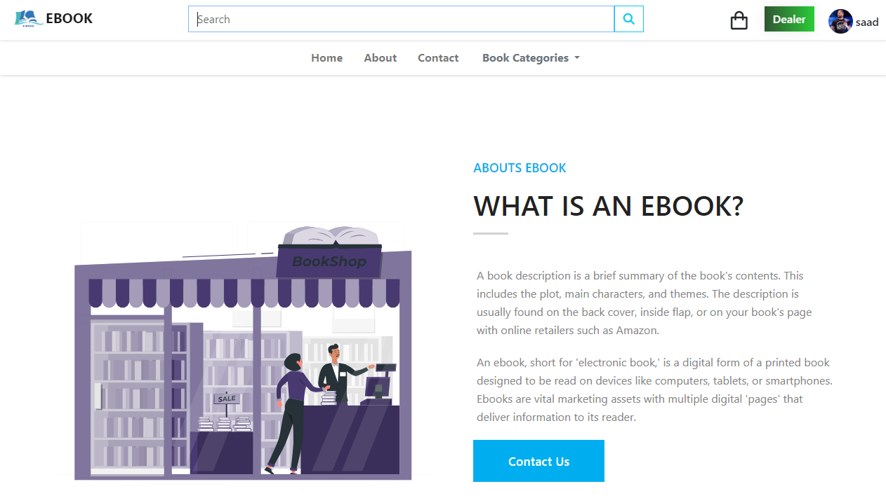

How to Use

- Browsing Book
1. On the homepage, you'll find a list of ongoing and upcoming books.
2. Click on a book to access PDF ,Hard copy, CD
3. Explore book details in PDF form

.

BOOK CATEGORY

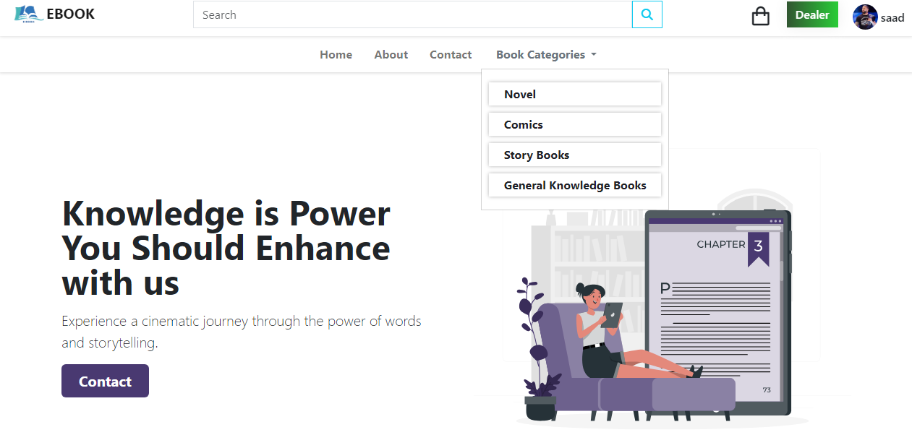

Membership Benefits
- Registered Users: Access to free PDF books and the ability to purchase books online.
- Book Descriptions: Unregistered users can view brief book descriptions, while registered users get access to detailed descriptions.

Customer Communication
- Order Confirmation: Acknowledge orders, confirm addresses, and ask for order confirmation.
- Payment Confirmation: Notify customers upon payment receipt and update access on the site.

CONTACT US

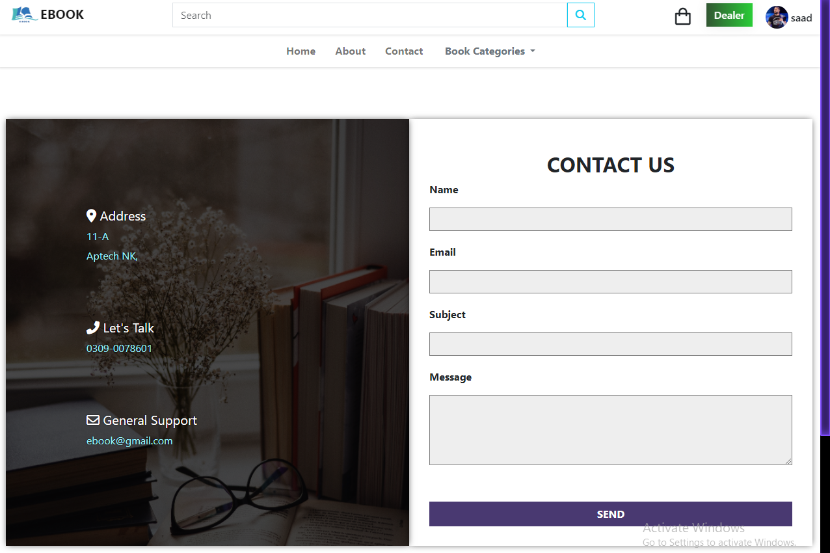

Book Purchases
- Book Formats: Offer books in PDF, hard copy, and CD formats for purchase.
- Delivery Charges: Charge delivery fees based on location and book/CD weight.
- Payment Methods: Enable payment via credit card, DD, cheque, or VPP.
- Access After Payment: Users can access purchased PDF books only after payment confirmation.

CART & CHECKOUT

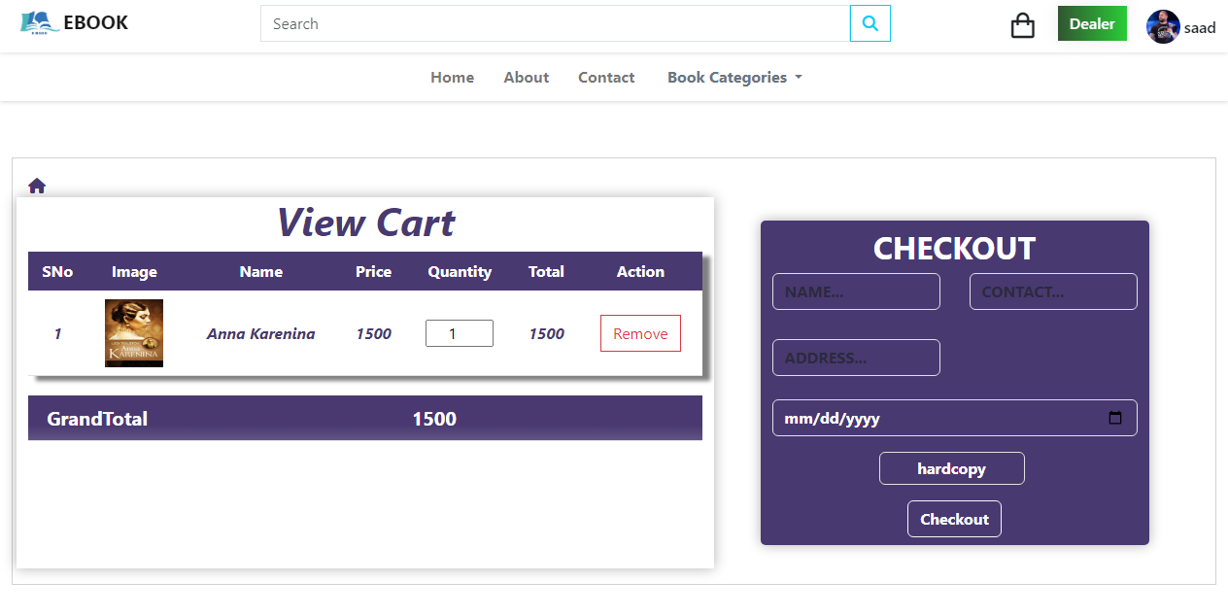

Financial Considerations
- Payment Channels: Offer various payment methods for book purchases.

- Competition Charges: No charges for participating in competitions; winners receive prizes.

WINNERS



Competitions
- Essay Writing: Allow registered users to participate by uploading documents within a time limit.
- Winners Announcement: Display winners' details and provide prizes for competitions.

Database Management
- Database Structure: Store book, order, and customer details in a structured database.
- Tracking Orders: Allow easy order tracking for the publisher.

Existing Scenario : –

The publisher (client) usually publishes in the form of a hard copy (books) and in the form of a CD and distributes them to the book dealers situated all over the city, who distributes the books to the public at the maximum retail price. Some times the dealers come up saying that they want more number of copies and they again need to print the books and redistribute among the dealers based on the request of the dealers. So it takes some time in distributing the books among the dealers and then to the customers. Also he announces about the essay writing competitions, story competitions on the journal for which three days are given for the receipt of the essay writings and for the story receipt they are needed to be sent with in a week in order to attract the customers and he provides the prizes as per the competition and the winner topic and the story or the essay that he/she has sent will be published in the next publication (journal or the essay book)

Thank you for choosing ONLINE EBOOK!
If you have any questions or
suggestions, feel free to reach out to us. Enjoy US

